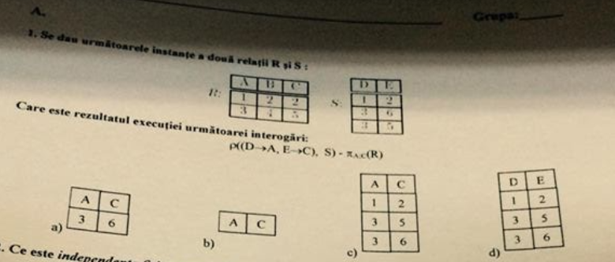
Se dau urmatoarele instante a doua relatii R si S:
Raspuns: a)

-----------------------------------------------------------------------------------------------------------------
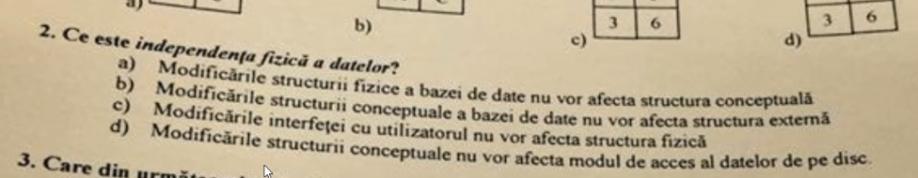
independenta fizica a datelor
Raspuns: a) modificarile structurii fizice a bazei de date nu vor afecta structura conceptuala
-----------------------------------------------------------------------------------------------------------------

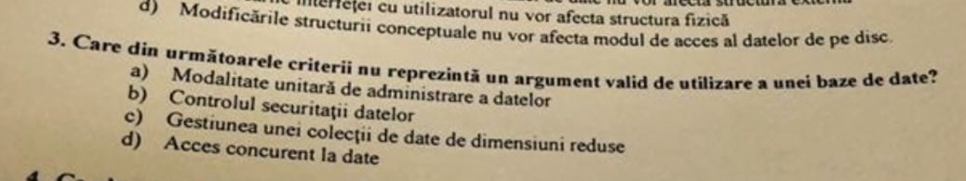

Care din urmatoarele criterii nu reprezinta un argument valid de utilizare a unei baze de date?
Raspuns: c) Gestiunea unei colectii de date de dimensiuni reduse
-----------------------------------------------------------------------------------------------------------------
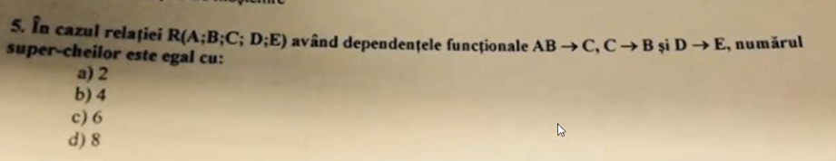
super cheie, Raspuns: 6 (?)
AB -> C
C -> B
D -> E

chei candidat: abd, acd
super chei:
abd
abdc
abde
abdce
acd
acde
---------------------------------------------------------------------------------------------------------------------------
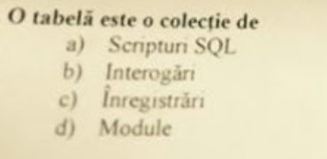
4. O tabela este o colectie de:
Raspuns: c) Inregistrari
-----------------------------------------------------------------------------------------------------------------------
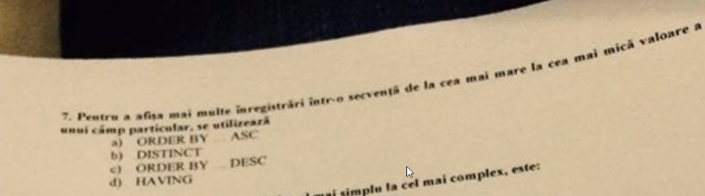
5. Pentru a afisa mai multe inregistrari intr-o secventa de la cea mai mare la cea mica valoare a unui camp particular, se utilizeaza
Raspuns: c) ORDER BY _ DESC

---------------------------------------------------------------------------------------------------------------------------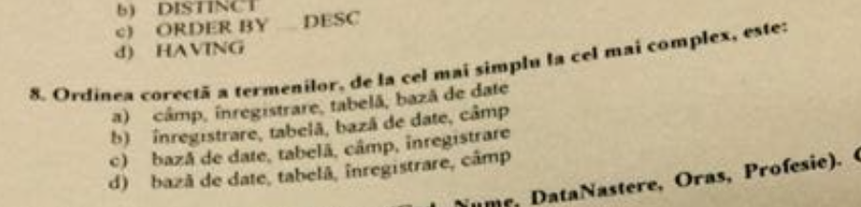
6. Ordinea corecta a termenilor, de la cel mai simplu la cel mai complex este:
Raspuns: a) camp, inregistrare, tabela, baza de date

----------------------------------------------------------------------------------------------------------------
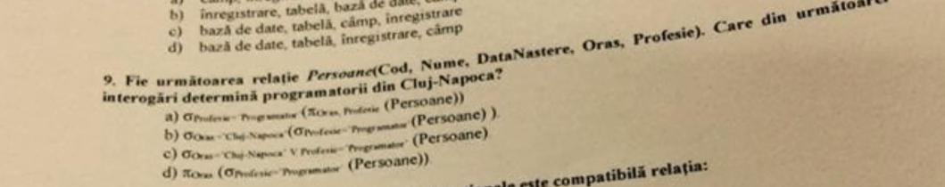
7. Algebra relationala
Raspuns: b)
daca la c) era SI era bun

---------------------------------------------------------------------------------------------------------------------------
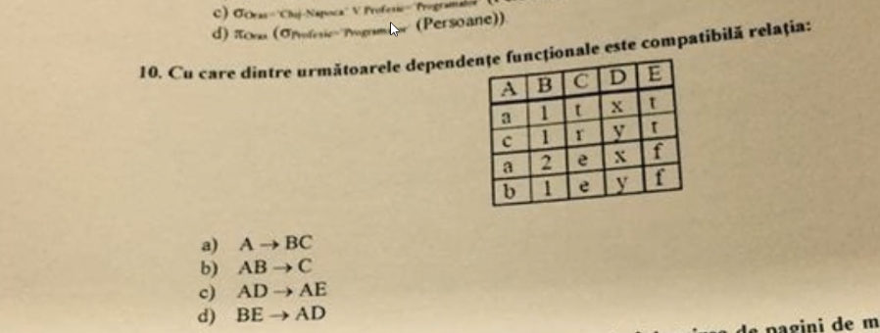
8. Dependente functionale:
Raspuns: b)
---------------------------------------------------------------------------------------------------------------------------
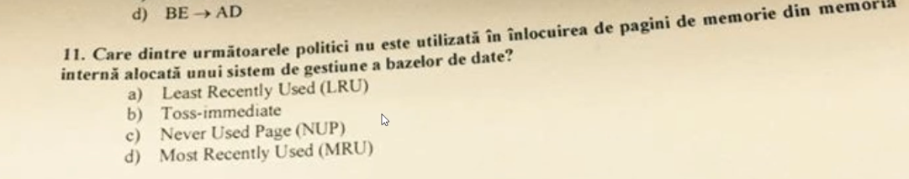
Raspuns: c) NUP
---------------------------------------------------------------------------------------------------------------------------
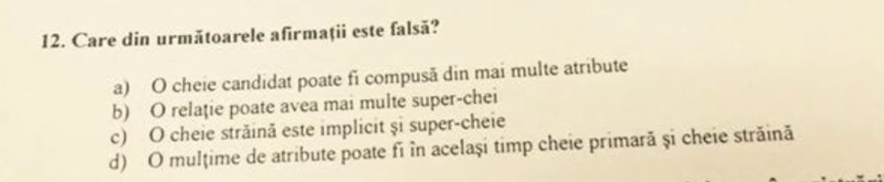
Afirmatie Falsa
Raspuns: c) O cheie straina este implict si super-cheie
-----------------------------------------------------------------------------------------------------------------------
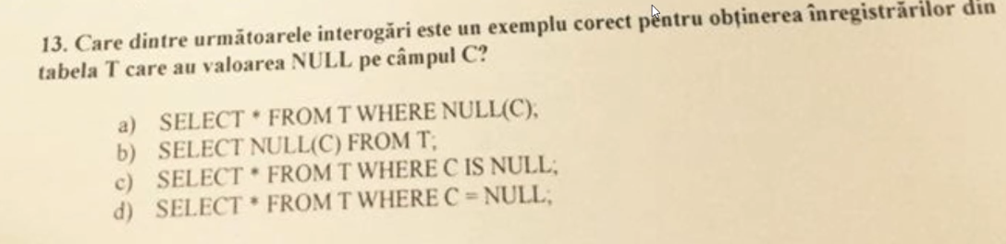
Raspuns: c) SELECT * FROM T WHERE C IS NULL (NULL = NULL DA FALSE)!!!!
--------------------------------------------------------------------------------------------------------------------------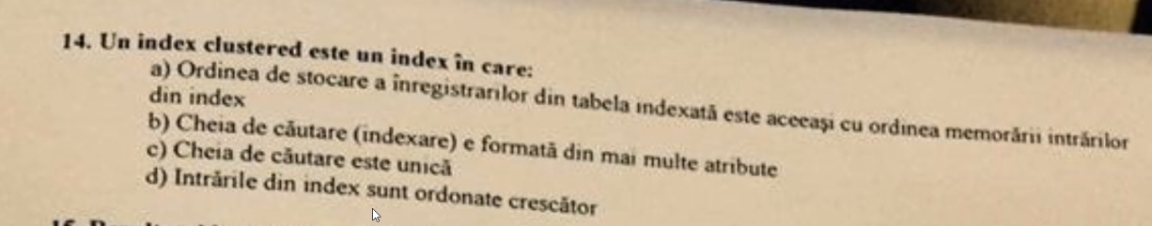
index clustered
Raspuns: a) Ordinea de stocare a inregistrarilor din tabela indexata este aceeasi cu ordinea memorarii intrarilor din index.
--------------------------------------------------------------------------------------------------------------------------
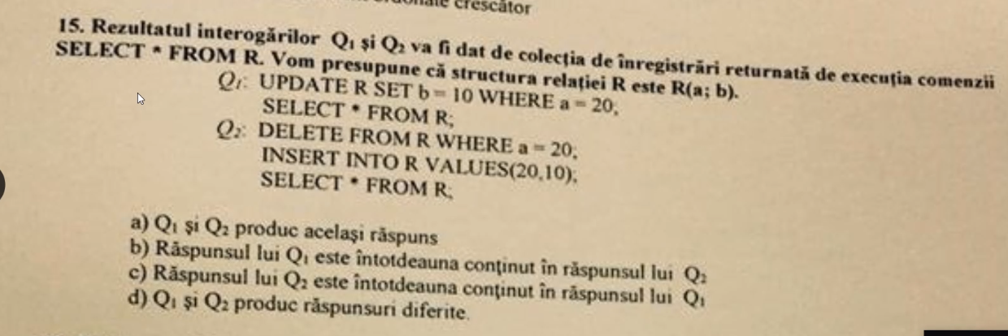
Q1 si Q2
Raspuns: D) Q1 si Q2 produc raspunsuri diferite
--------------------------------------------------------------------------------------------------------------------------
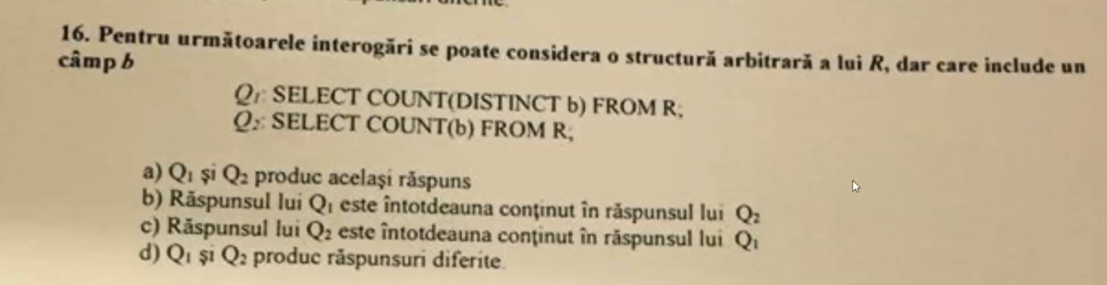

Q1 si Q2 - count
Raspuns: d) Q1 si Q2 produc raspunsuri diferite
b) Q1 inclus in Q2 (daca ar fi multimi, insa count da 2 numere ex 4 != 5)

COUNT(*) returns the number of items in a group. This includes NULL values and duplicates.

COUNT(ALL expression) evaluates expression for each row in a group, and returns the number of nonnull values.

COUNT(DISTINCT expression) evaluates expression for each row in a group, and returns the number of unique, nonnull values.

--------------------------------------------------------------------------------------------------------------
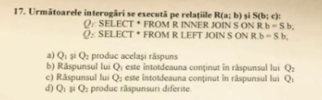
Q1 si Q2
Raspuns: b) Q1 inclus in Q2 (la cele de genul, uita-te peste diagramele Venn)

-------------------------------------------------------------------------------------------------------------
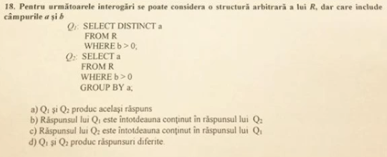
Q1 si Q2
Raspuns: a) la fel
!!!!!!!! distinct si group by iau in considerare null.

----------------------------------------------------------------------------------------------------------------
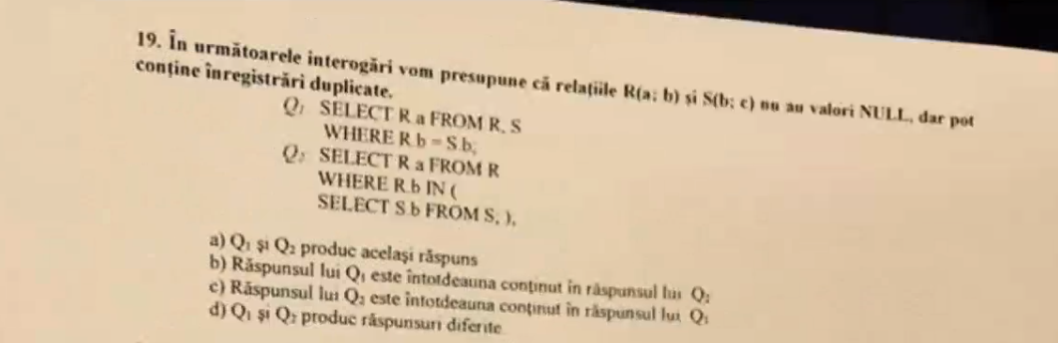
Q1 si Q2
Raspuns: a) Q2 in Q1
Where le verifica pe toate, pe cand IN dupa ce a gasit primul match returneaza valoarea (intelegeti voi, era exemplu cu Iohannis).

------------------------------------------------------------------------------------------------------------------------
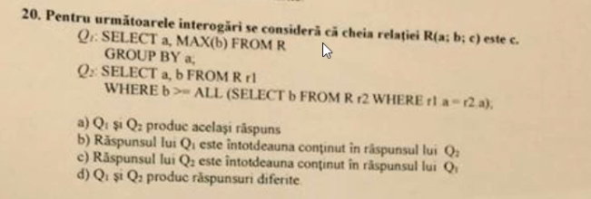
Q1 si Q2
Raspuns: b ?

---------------------------------------------------------------------------------------------------------------------------
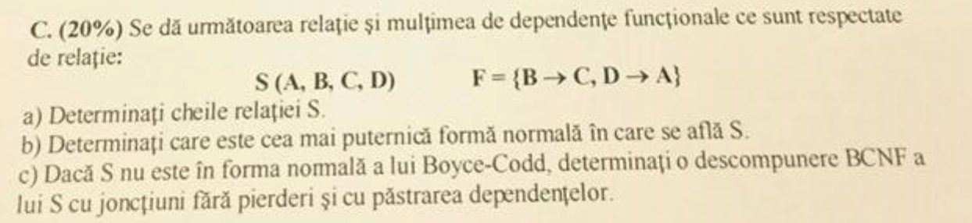
- B,D
- 1NF
- 1.B->C nu respecta BCNF
Descompunem in {BDA} ,{BC}
2.D->A nu respecta BCNF
Descompunem R in {BD}, {BC},{DA}\

def : daca avem dependenta A - > B => R-B, AB

SUBIECT 5
---------------------------------------------------------------------------------------------------------------------------
- Este posibil ca valoarea unei chei straine sa fie NULL? Raspuns: C
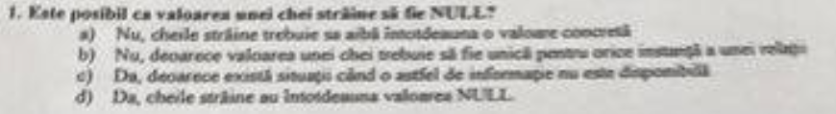
---------------------------------------------------------------------------------------------------------------------------
- Ce este independenta logica a datelor? Raspuns: B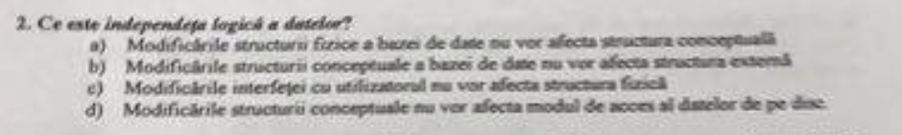
-----------------------------------------------------------------------------------------------------------------
- Care din urmatoarele criterii NU reprezinta un argument valid de utilizare a unei baze de date? Raspuns: B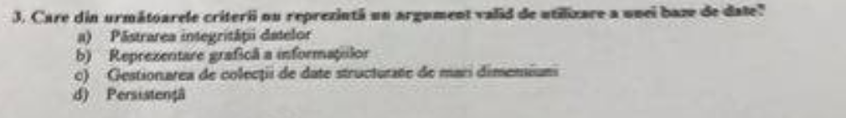
-----------------------------------------------------------------------------------------------------------------
- Un index clustered este un index in care. Raspuns: A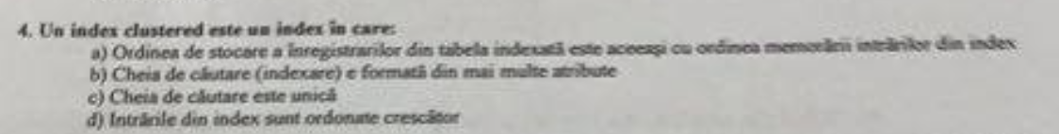
-----------------------------------------------------------------------------------------------------------------
- Care dintre urmatoarele exemple NU reprezinta o alternativa de memorare a unei intrari dintr-un fisier index? Raspuns: B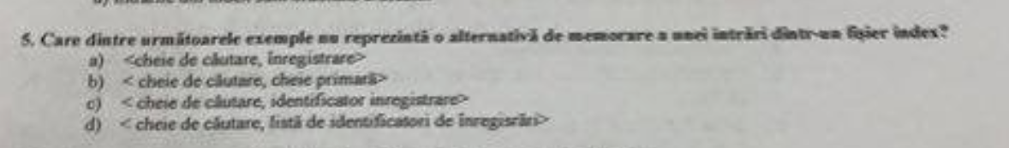
--------------------------------------------------------------------------------------------------------
- Ordinea corecta a termenilor, de la cel mai complex, la cel mai simplu, este. Raspuns: D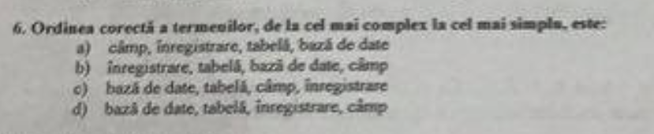
-----------------------------------------------------------------------------------------------------------------
- Scopul unei tabele este de a: Raspuns: C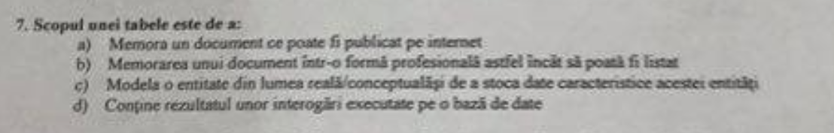
----------------------------------------------------------------------------------------------------------------
- Pentru a afisa mai multe inregistrari intr-o secventa de la cea mai mare la cea mai mica valoare a unui camp particular, se utilizeaza: Raspuns: C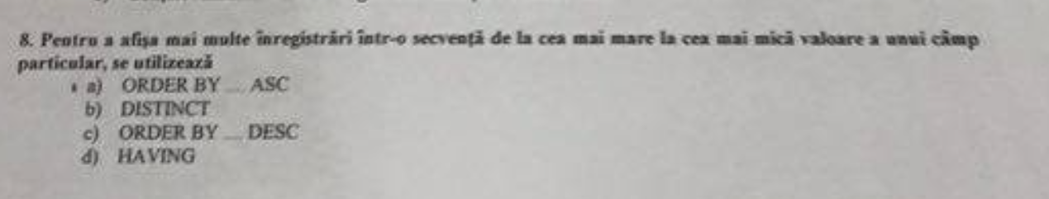
-----------------------------------------------------------------------------------------------------------------
- Care dintre urmatoarele NU este o alternativa de translatare a unei relatii de mostenire intre doua clase A (super-clasa) si B (sub-lcasa) in tabelele unui model relational? Raspuns: B 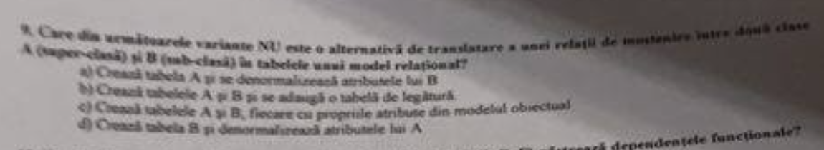
---------------------------------------------------------------------------------------------------------------------------
- Descompuneri ale relatiei 
Raspuns:C
----------------------------------------------------------------------------------------------------------------------------
- 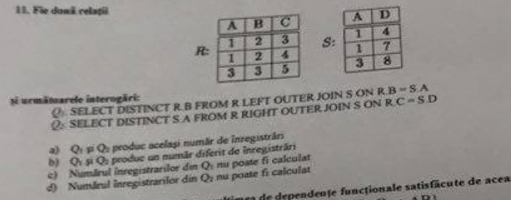
Raspuns:a)Q1 si Q2 produc acelasi numar de inregistrari
-----------------------------------------------------------------------------------------------------------------
- 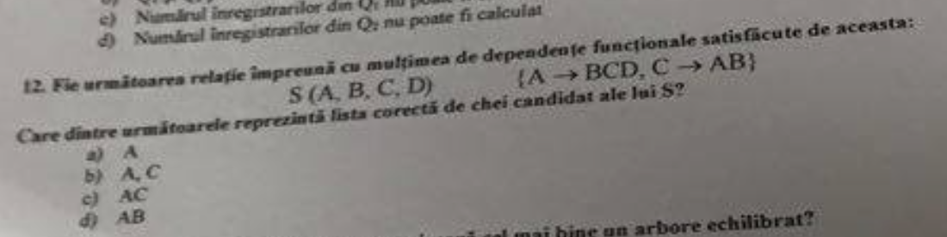Raspuns: B - chei candidat
---------------------------------------------------------------------------------------------------------------------------
- Care dintre urmatoarele afirmatii caracterizeaza cel mai bine un arbore echilibrat? Raspuns: C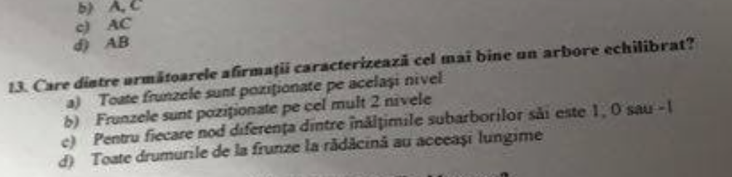
-----------------------------------------------------------------------------------------------------------------
- Care este principala responsabilitate a unui Buffer Manager? Raspuns: B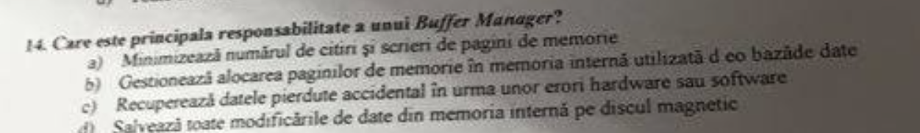
-----------------------------------------------------------------------------------------------------------------
- Q1 si Q2
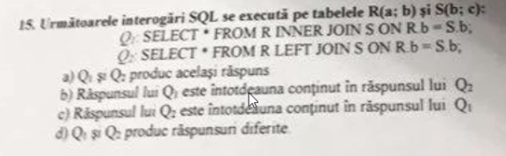
Raspuns: b) Q1 inclus in Q2
-----------------------------------------------------------------------------------------------------------------
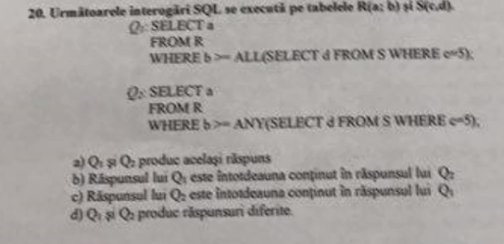
Q1 si Q2
The ANY operator returns true if any of the subquery values meet the condition.
The ALL operator returns true if all of the subquery values meet the condition.
Raspuns: b) Q1 inclus in Q2
-----------------------------------------------------------------------------------------------------------------

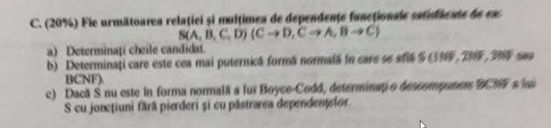

S(A,B,C,D) {C->D, C->A, B->C}

- cheie candidat: B
supercheie: B,
BA, BC, BD,
BAC, BAD, BCD,
BACD
- e in 2NF

2NF toata cheia trebuie sa fie conectata cu un atribut NEPRIMAR, e permisa tranzitivitatea

3NF poti deduce tot din cheie, NU e permisa tranzitivitatea

A depinde tranzitiv de B prin C
Atribut PRIM - atributele care fac parte din cheie
- C->D nu respecta BCNF
Descompunem in {CAB}, {CD}
C->A nu respecta BCNF
Descompunem in {CB} {CD} {CA}
-----------------------------------------------------------------------------------------------------------------
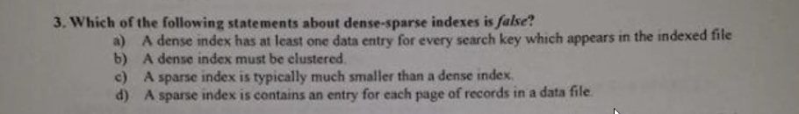
index dens si rar (un index dens poate fi si clustered si nonclustered, un index rar trebuie sa fie musai clustered)
Raspuns: b)
-----------------------------------------------------------------------------------------------------------------
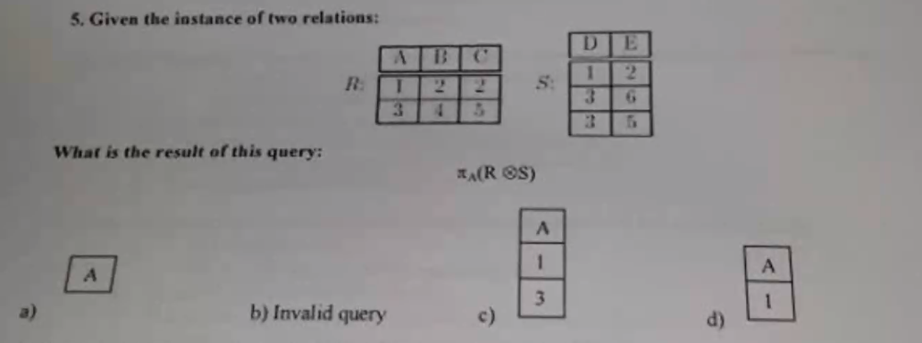
Raspuns: B) invalid
-----------------------------------------------------------------------------------------------------------------
x) AB -> C, ABC -> D, AC -> B
chei candidat: AB, AC
2 NF pentru ca din cheie ajungi la TOATE :) (prin tranzitivitate)
NU e in 3NF pentru ca implica tranzitivatea si nu ar trebui
-----------------------------------------------------------------------------------------------------------------
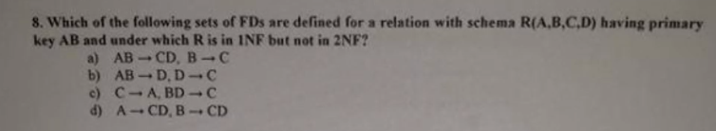
1NF, 2NF
Raspuns: a)
-------------------------------------------------------------------------------------------------------
AB -> CD NU este echivalent cu A -> CD si B -> CD
AB -> CD este echivalent cu AB->C si AB -> D
--------------------------------------------------------------------------------------------------------

trivial : AB -> A
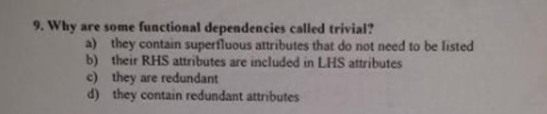
Raspuns: b)

-----------------------------------------------------------------------------------------------------------------
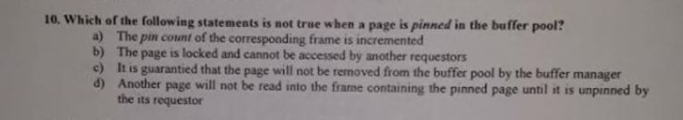
pin count
Rapsuns: b)
-----------------------------------------------------------------------------------------------------------------
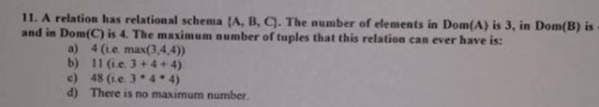
Raspuns: d) Nu exista un numar maxim

-----------------------------------------------------------------------------------------------------------------
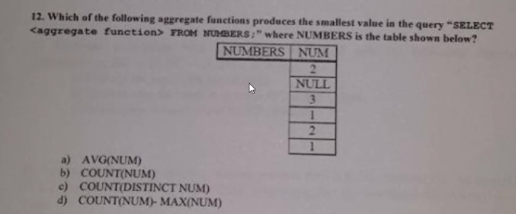
a = 1,8
b = 5
c = 3
d = 5-3 = 2
Raspuns: a)
-----------------------------------------------------------------------------------------------------------------
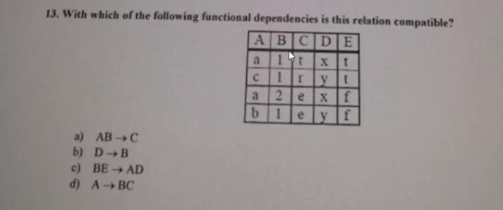
Raspuns: a)
ACELASI INPUT -> ACELASI OUTPUT
INPUT diferit -> acelasi OUTPUT
!! CNP u lui Serju
b) NU: x -> 1 si x->2
acelasi INPUT da valori diferite (nu e ok)

-----------------------------------------------------------------------------------------------------------------
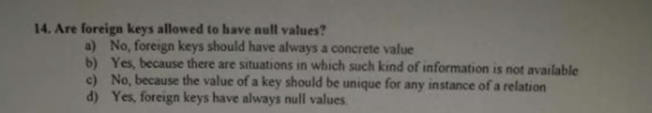
Raspuns: foreign key poate avea valori NULL
----------------------------------------------------------------------------------------------------------------
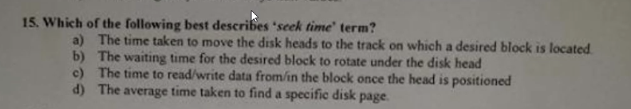seek time
Raspuns: a) ? sau d ?
---------------------------------------------------------------------------------------------------------------

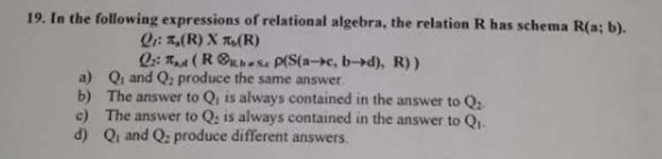
Q1 si Q2
Q1 : nr randuri: R^2, tabela cu 2 coloane (a si b)
Q2 : S.c = R.a si S.d = R.b
Raspuns: Q2 inclus in Q1
-------------------------------------------------------------------------------------------------------
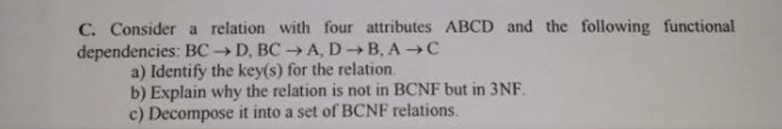
BCNF:

BC -> D ===> BC -> AD
BC -> A
D -> B
A -> C

a) BC, AD
c) D -> B ==> R1 = R \ {B} = {ACD} U {DB}
A -> C ==> R2 = R1 \ {C} = {AD} U {DB} U {AC}

R = {A -> D, D -> B, A -> C}

-----------------------------------------------------------------------------------------------------------------

ENGLEZA https://drive.google.com/drive/folders/1024cVpjFnEmLSFCheWFrAIckxPo3I61Y?fbclid=IwAR15qQA5GL1U3k_BBwNKMsBNdp35nLHYm1EHiMTc3BEY1OAMAkaCsoRVMr8
---------------------------------------------------------------------------------------------------------------
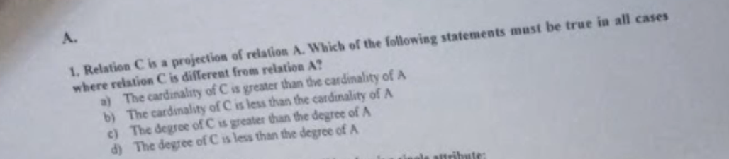
Raspuns: d) cardinal C < cardinal A

-----------------------------------------------------------------------------------------------------------------


Raspuns:a)
-----------------------------------------------------------------------------------------------------------------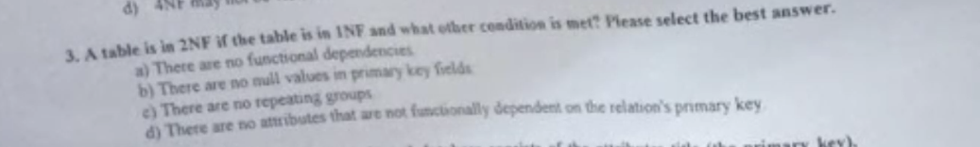
Raspuns: d
-----------------------------------------------------------------------------------------------------------------
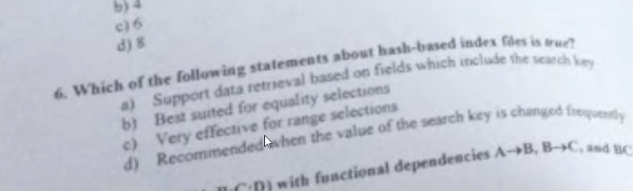
tabela hash
Raspuns: c ?
-----------------------------------------------------------------------------------------------------------------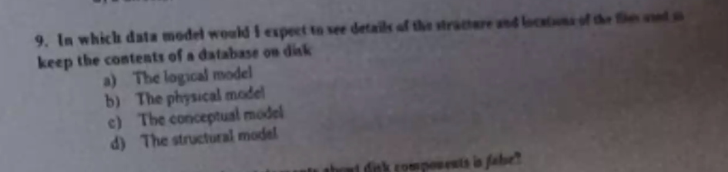
R: b) model fizic
-----------------------------------------------------------------------------------------------------------------
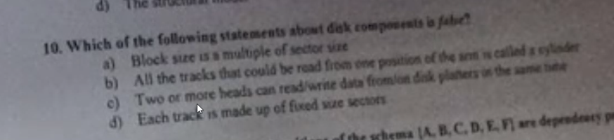
R: Disk componente
- sigur e ADEVARAT
-----------------------------------------------------------------------------------------------------------------

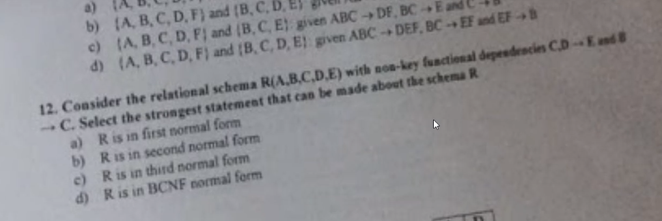
R: a)
-----------------------------------------------------------------------------------------------------------------
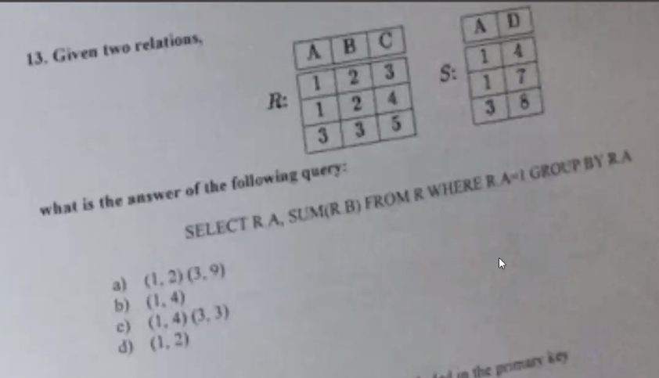
R: b)
-----------------------------------------------------------------------------------------------------------------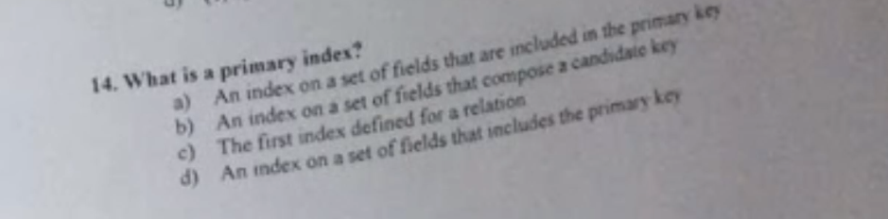
index prim - face parte din cheia primara
index ne prim - nu face parte din cheie
R: a)
-----------------------------------------------------------------------------------------------------------------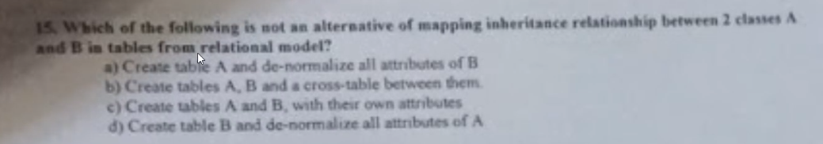
R: b)
-----------------------------------------------------------------------------------------------------------------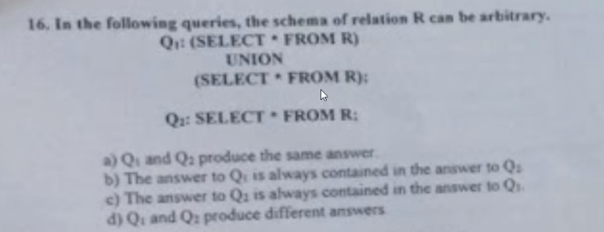
Q1 si Q2
R: a) UNION - acelasi raspuns
The UNION operator selects only distinct values by default. To allow duplicate values, use UNION ALL
------------------------------------------------------------------------------
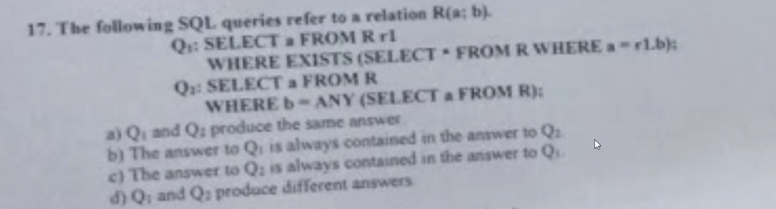
Q1 si Q2
Exists , ANY
R: a)
-------------------------------------------------------------------------------
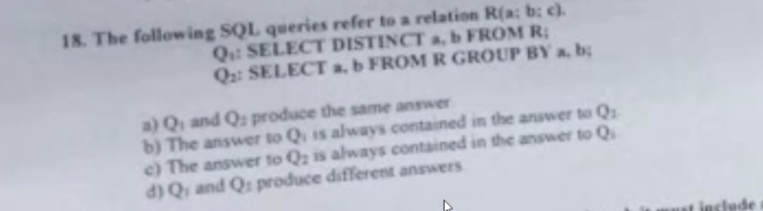
Q1 si Q2
DISTINCT , GROUP BY
R: a
----------------------------------------------------------------------
SCRIPT
create table R(
a int,
b int,
c int
);

create table S(
a int,
d int
);
---------------------------------------------------------------------
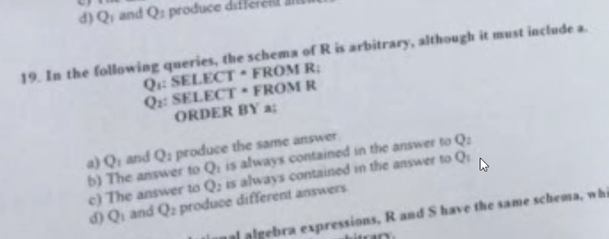
Q1 si Q2
R: a
-------------------------------------------------------------------------------

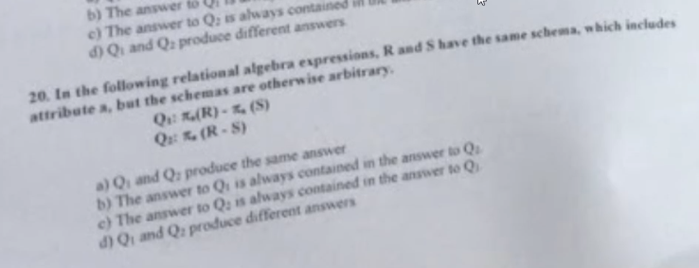
Q1 si Q2
R: d)
-------------------------------------------------------------------------------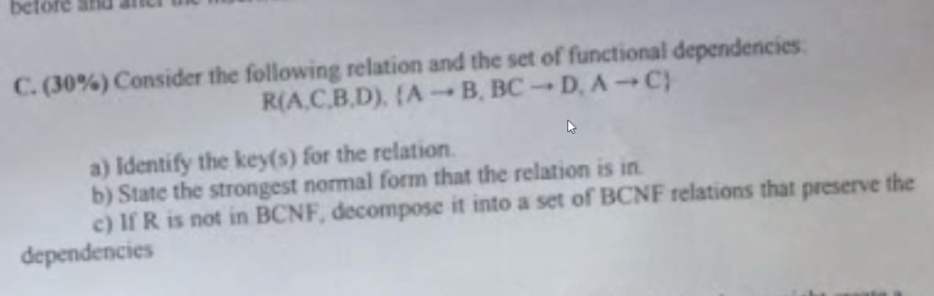

- key: A
- 2NF
- A->B, A->C⇔ A->BC
BC->D nu e in BCNF
descompunem in {ABC},{BCD}
A->BC, BC->D

